Power Outage Plan:  Staying safe when the power goes out | 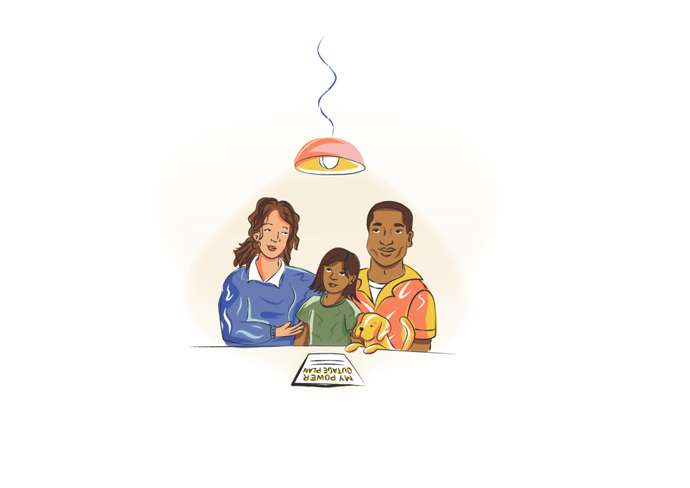

Power outages can happen suddenly, disrupting daily life. It’s important to have a plan to stay safe and informed. This Plan covers six key areas:

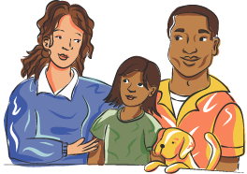  People | 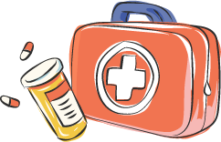  Essentials |   Communication | 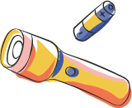  Light | 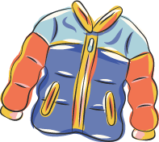  Comfort | 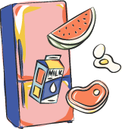  Surroundings

How to complete this Plan:
- Each of the 6 areas has a goal and steps to follow.
- Read the steps, fill out your actions in the
‘My Plan’ section, and check them off when done.

Once you’ve completed this Plan:
- Save it and email to those who can help.
- If you’ve printed it, keep it in a safe place, make copies or take photos of it and share it with others who can help.

My Plan
Household address:
Household members (including pets!):
Plan Owner/s name:
Plan Owner/s phone: | Plan Owner/s email:

My Emergency Contact List
Call 000 for Police, Fire Services and Ambulance
Call 132 500 for State Emergency Service (SES) assistance in floods and storms
Doctor | Name: | Phone: | Email:
Emergency Vet | Name: | Phone: | Email:
Insurance home | Name: | Phone: | Email:
Insurance vehicle | Name: | Phone: | Email:
Other: | Name: | Phone: | Email:
Other: | Name: | Phone: | Email:
Other: | Name: | Phone: | Email:

1. People
The Goal: Keep your household and community safe and informed during a power outage.

What You Can Do | My Plan | Done (tick)
Power outage information:  Know your energy provider’s contact details and sign up for updates.  TIP! Visit the website poweroutageplan.com. au/#more-information to find your energy provider. | My energy provider is:  Phone:  Web:  I have signed up for updates / news: Yes or No
Plan owner: Select one or more people to oversee the Power Outage Plan. | The person or people in charge of the Plan:
Talk about it:  Go over the Plan with your household and assign roles.  TIP! Include your pets. | When the power goes out, our household has agreed to:
Check on people:  List people (at home and the neighbourhood) who may need help and keep their contact details. | 1. Name:  How to contact with no power:  Help they need:
2. Name:
How to contact with no power:
Help they need:

3. Name:
How to contact with no power:
Help they need:

4. Name:
How to contact with no power:
Help they need:

Live alone:  If you live alone, list people who will check on you. | 1. Name:  How to contact me with no power:  2. Name:  How to contact me with no power:

2. Essentials
The Goal: Have access to food, water, education, and energy sources during an outage.

What You Can Do | My Plan | Done (tick)
Food & water: Store 3 to 7 days' worth of food and drinking water for everyone, including pets.  TIP! Consider storing more food for dietary needs.  TIP! Get a generator if water/sewage relies on power. | I will access drinking water by:  I will access water for washing, hygiene, & cooking by:  I have at least 3 to 7 days’ supply of:  - Non-perishable food: Yes or No  - Pet food (if needed): Yes or No  If I’m reliant on electric water/ sewage pumps, do I have a generator? Yes or No
Cooking: Have a backup cooking method (e.g. camp stove or BBQ).  TIP! Have enough gas.  TIP! Have a safe way to heat baby formula. | I will heat food or drinks by:
Preserve food: Use Eskys with ice packs for long outages.  TIP! Keep fridge/freezer doors closed.  TIP! Learn more at www.health.vic.gov.au/food-safety/food-safety-during-power-outages | I will preserve food in my fridge and freezer by:
Health: Keep a First-aid Kit and 3 to 7 days’ worth of medications (including pets!).  Create a Life Support Power Outage Plan if you use medical equipment at home, learn more at this website lifesupport.poweroutage.com.au  TIP! Add your doctor’s contacts to your emergency contact list (see page 1). | I have at least 3 to 7 days’ supply of:  - Prescription medications: Yes or No  TIP! Check the label for storage, keep medications cool if they need to be refrigerated  - First-aid Kit: Yes or No  - Other potential medications e.g. Paracetamol or antihistamine: Yes or No  - Toilet paper: Yes or No  - Hand sanitizer: Yes or No  - Sanitary products: Yes or No  - Other (list anything else important to your health e.g. disinfectant): Yes or No  - Pet medications (if needed): Yes or No
Vehicles: Before bad weather, fuel your vehicle or charge your electric car.  TIP! Have a backup transport option. | I have enough petrol / charge in my vehicle/s: Yes or No  If I need alternative transport, I will:

3. Communication
The Goal: Communicate with family, friends, and emergency contacts during a power outage.

What You Can Do | My Plan | Done (tick)
Back-up power: Keep a charger or power bank for your phone.  TIP! Charge devices before bad weather. | I will charge my phone by:
Battery-powered radio: Stay updated with a radio if phone or internet fails.  TIP! Find your local frequency at www.reception.abc.net.au and write it down. | I have a battery-powered radio or a hand-crank radio:  Yes or No
Household communication: Plan how to stay in touch and what do do during a power outage.  TIP! Consider when people are away at school, work etc.  TIP! If your NBN or phone can’t work, think about emergency contact options. | Name:  I agree to:
Name:
I agree to:
Name:
I agree to:
Name:
I agree to:
Community communication: Share contacts and check on each other during a power outage.  TIP! Join local support groups.  TIP! Share your Plan with people who can help. | I will contact this person/group in my local area  Name:  How to contact them without power:  If the internet or phone goes down, I can be contacted by:  I have shared this with:
Out-of-area communication: Choose an out-of-area contact person and inform your household. | If the internet or phone goes down, the go-to person outside my local area who can be contacted in case of emergency is:  Name:  How I will contact them:  How family / loved ones can contact them:  How they will contact my household:

4. Light
The Goal: Have access to light to keep you safe when the power goes out.

What You Can Do | My Plan | Done (tick)
Torches and lanterns: Keep lights in easy-to-find spots.  TIP! Candles can be a fire risk | I have lights I can use: Yes or No
Keep lights going: Use LED lanterns and spare batteries for lights, flashlights, and devices. | I have LED battery-powered light sources: Yes or No  I have extra batteries: Yes or No
Back up lights: Place backup lights in easy-to-access spots. | I have backup lights in these areas at home  Bedrooms: Yes or No  Living Room: Yes or No  Kitchen: Yes or No  Other (e.g. bathroom, shed, fuse box): Yes or No

5. Comfort
The Goal: Household is calm and comfortable dealing with heat or cold during a power outage.

What You Can Do | My Plan |  | Done (tick)
Temperature: Stay warm or cool during the outage, depending on the season.  TIP! Cool Centres with aircon and water will open during heatwaves. Visit your local council’s website for details. | To stay warm:  - Layer clothing  - Use blankets or sleeping bags  - Close curtains  - Seal drafts/gaps with towels or fabric  - Use hot water bottles  - Stay in one room and conserve heat  - Move around to boost warmth  - Wear a hat and keep my head covered | To stay cool:  - Wear light clothes  - Use battery-powered / USB-charged / hand-held fans  - Close curtains and block out the sun  - Drink plenty of water  - Use a cold compress to pulse points  - Stay in the coolest area of the home  - Use ice packs  - Avoid physical activities  - Take cool showers
Coping strategies: Consider ways to stay calm in stressful situations.  TIP! Consider children & pets. | To stay calm:  - Listen to relaxing music  - Read a book, magazine  - Play board games with others  - Write down ideas and information  - Practise deep breathing, sitting quietly  - Get together with neighbours  If safe, get outdoors: go to the beach/pool/river, a park, a ride/jog/walk.  For children; games, colouring, storytelling.  Mental Health Support: Contact Beyond Blue at 1300 224 636 for free, confidential support.

6. Surroundings
The Goal: Maintain safety and functionality of your home during a power outage.

What You Can Do | My Plan | Done (tick)
Manual overrides: Know how to open/close doors and gates without power. | I know how to manually operate  My garage door by:  My electric gate by:  Other (include space ) by:
Turn off appliances: Switch off at the power point and use surge protection.  TIP! Consider backup power for key appliances. | I will switch off appliances: Yes or No  I have surge protection: Yes or No  For important appliances I have backup power:  Yes or No  TIP! Name these appliances:
Safe walkways: Keep paths clear for safe movement in low light. | I have cleared walkways inside: Yes or No  I have cleared walkways outside: Yes or No
Safety precautions: Secure loose items and outdoor structures.  TIP! Do not go near damaged power lines or substations. | To keep our home safer, our household has agreed to:  TIP! You can add specific jobs / responsibilities for each person):
Evacuation: Prepare your steps and essential items in case you need to evacuate.  TIP! Store documents in a waterproof container. | If I need to evacuate, I will go to:  To get there I will:  I have essential items packed in case I need to evacuate (including a First-Aid Kit, ID, medical documents, cash, torch)  Yes or No  The last time I reviewed these was:  The last time I (and the household) practiced this was:
Your Plan: Keep a copy of your Plan and contacts with a torch nearby. | I keep a copy of my Plan and emergency contacts with a torch, here:

